VITyarthi | Open Source Software

The Open Source Audit

A Capstone Project for OSS NGMC Course

Course: Open Source Software | Unit Coverage: 1 – 5
Max Marks: 100

Student Name | Registration Number
Amar Dixit | 24BAS10093
Slot | Date of Submission
B22 | 31/03/2026

1. Choosing Your Software

choice | Mozilla Firefox

2. Project Report Structure

Part A — Origin and Philosophy (Units 1 & 2)

A1. The problem this software was created to solve
To understand why Firefox exists, we have to look back at the late 1990s. At that time, a company named Netscape made the most popular web browser. But then Microsoft created Internet Explorer and put it in every Windows computer for free. Netscape could not compete with this. Microsoft won the browser war and Internet Explorer became a massive monopoly.
Because Microsoft had no real competition, they stopped working hard to make their browser better. Internet Explorer became slow. It had many security problems. It also ignored the rules and standards of the web, making it very hard for developers to build websites that worked properly everywhere. People were very frustrated, but they had no other good choice.
The people at Netscape realized they were losing. They decided to do something completely different. Instead of keeping their code a secret, they released it to the public in 1998. They started the Mozilla project. Their goal was to let programmers from all over the world help build a better browser.
Eventually, some developers in the Mozilla community realized the main Mozilla software was getting too heavy and complicated. They wanted a fast, lightweight browser that just focused on browsing the web. They created a new project called Phoenix, which later changed its name to Firefox. The creators built it and shared it for free because they believed the internet belongs to everyone. They wanted to give users a choice and stop one big company from controlling how we experience the web.

A2. The license — what it actually says
Firefox mostly uses a license called the Mozilla Public License (MPL).
The four freedoms of free software are:
- The freedom to run the program as you wish for any purpose.
- The freedom to study how the program works and change it so it does your computing as you wish.
- The freedom to redistribute copies so you can help others.
- The freedom to distribute copies of your modified versions to others.
The MPL grants all four of these freedoms. You can use Firefox, read its code, change it, and share it.
Can a company take Firefox, modify it, and sell it without sharing their changes? The answer is a bit in the middle because of how the MPL works. The MPL is a file level copyleft license. This means if a company changes an existing Firefox file, they must share the code for that specific file. But, if they add completely new files with their own code, they can keep those new files closed and proprietary. They just have to share the Mozilla parts they changed.
If we look at the difference between GPL and MIT licensing, it is about how strict they are. The GPL is very strict. If you use GPL code in your project, your whole project must also become open source. The MIT license is very loose. It lets you take the code, change it, and put it in a closed, paid product without sharing anything. If I built my own software, I would choose the MIT license if I wanted as many people as possible to use my code, even big companies. I would choose the GPL if I wanted to force everyone to share their improvements with the world.
There is a big difference between free as in free beer and free as in freedom. Free beer means you do not have to pay money. Google Chrome is free beer because it costs zero dollars, but you cannot see the code or change it. Free freedom means you have liberty and control. Firefox is both. You do not pay money for it, and you also have the freedom to see exactly how it works and modify it.

A3. The ethics of open source
Open source brings up big questions about how we share knowledge.
Should all software be open source? A good argument for open source is that it helps humanity progress faster. When everyone can see the code, bugs get fixed quickly, and people can learn from each other. It stops big companies from trapping users. However, a good argument against it is that making software takes a lot of time and money. If everything is free and open, it is very hard for programmers to get paid for their hard work. Some highly specialized software might never get built if companies cannot sell it to make a profit.
Is it ethical for a company to build a profitable product entirely on top of free community labor? This is a tough question. Technically, if the license allows it, it is legal. But ethically, it feels wrong if a giant company makes billions of dollars using a free tool and gives nothing back to the volunteer programmer who made it. Companies like Google and Meta use lots of Linux and open source tools. They do try to hire open source developers and donate money to projects, which makes it more ethical. It is a shared system, but big companies must be careful not to abuse the community.
Standing on the shoulders of giants means that new inventions are only possible because of the work people did in the past. Open source completely enables original innovation. Because a developer does not have to spend years writing a basic web engine or an operating system from scratch, they can focus their time on building a brand new, amazing feature on top of it.

Part B — Linux Footprint (Unit 2)
This section explains how Firefox works on a Linux system, specifically based on testing it on Ubuntu Linux.
Installation method Firefox is very easy to install on Linux. It is usually there by default. If it is not, you do not have to compile it from source unless you really want to. You can install it using a package manager. On Ubuntu, you can use the apt command: sudo apt install firefox Many modern Linux systems also use Snap or Flatpak to install Firefox, which puts the software inside a safe container.
Key directories When installed traditionally via apt, the files go to a few main places:
- The main program file to run it is located at /usr/bin/firefox.
- The big library files and extra program data are stored in /usr/lib/firefox.
- The system-wide configuration settings are in /etc/firefox.
- The personal data for the user, like bookmarks, history, and passwords, are hidden in the user's home folder at ~/.mozilla/firefox/.
User and group Firefox runs as the normal user who is currently logged in. If my username is "student1", Firefox runs under the "student1" user and group. It never runs as the root superuser. This is extremely important for security. Browsers run code from the internet all the time. If a bad website hacks into Firefox, the hacker only gets the permissions of the normal user. They cannot delete core system files or install viruses on the whole machine because they do not have root access.
Service management Firefox is a desktop application, not a background system service like a web server or database. Because of this, you do not use service commands to manage it. You cannot run systemctl start firefox. Instead, you just click the icon on your desktop, or you type firefox in the terminal and press enter. To stop it, you just close the window or press Ctrl+C in the terminal.
Update model The open source community at Mozilla finds bugs and writes security patches. Then, they release a new version. If you are using Linux, your distribution maintainers check the new version and add it to their software repository. To get the update, you just update your whole system using the terminal: sudo apt update sudo apt upgrade If you use the Snap version, it updates itself automatically in the background without you having to type anything.

Part C — The FOSS Ecosystem (Units 3 & 4)

Firefox does not exist alone. It is part of a massive ecosystem of free software.

Dependencies To run on Linux, Firefox needs many other open source projects. It relies on GTK to draw its buttons and menus on the screen. It uses a tool called Cairo for drawing 2D graphics. It depends on FFmpeg to play audio and video files. It also needs basic Linux tools like glibc.

Enabled or inspired projects Firefox has inspired many other tools. The most famous is the Tor Browser, which is built on top of Firefox but modified to provide extreme privacy and keep users anonymous. There are also spin-offs like Waterfox and LibreWolf, which are made by people who took the Firefox code and changed it to remove all tracking features.

Relation to the web Firefox is the client in the client-server model of the web. It is not part of the LAMP stack (Linux, Apache, MySQL, PHP). The LAMP stack lives on the server and builds the website. Firefox is the tool on your computer that connects to that server, reads the code, and shows the website to you.

Community The Firefox community is massive and global. It is governed by the Mozilla Foundation, which is a non-profit organization. Developers and users talk to each other on Matrix chat rooms and the Mozilla Discourse forums. They use a tool called Bugzilla to report problems and track code changes. Anyone in the world can make an account and suggest a fix.

Part D — Open Source vs Proprietary (Critical Analysis)

Dimension | Open Source | Proprietary Alternative
Cost | Free to download and use. | Free to download and use.
Security (who can audit the code?) | Anyone in the world can audit the code to find hidden trackers or bugs. | Only Google employees can audit the core browser code. Users just have to trust them.
Support and reliability | Supported by the Mozilla Foundation and a large volunteer community. Very reliable. | Backed by a massive corporation with huge resources. Very reliable.
Freedom to modify | Total freedom. You can download the code, change how it looks or works, and build your own browser. | No freedom. You cannot see the source code or change the core software.
Community vs corporate control | Controlled by a non-profit foundation that focuses on privacy and keeping the web open. | Controlled by an advertising company that makes money by tracking user data.
Your overall verdict | Free and Flexible | Structured Support but no Freedom

After researching this topic, I would absolutely recommend Mozilla Firefox for a real-world deployment. Google Chrome is a very fast and good browser, but Google makes its money from advertising. This means they have a reason to track what you do on the internet. Firefox is backed by a non-profit that does not want to sell your data. For any user or company that cares about privacy and security, Firefox is the better choice because you can actually verify what the software is doing behind the scenes.
I would also be interested in contributing to the project. I might not be a good enough programmer yet to write complex C++ code for the browser engine, but open source projects need lots of different help. I could contribute by testing new beta versions and reporting bugs on Bugzilla. I could also help write documentation or translate menus into other languages. This is the beauty of the FOSS ecosystem, there is a place for everyone to help out.

3. Shell Script Tasks

Script 1 — System Identity Report (Unit 1 & 2)
#!/bin/bash
# Script 1: System Identity Report
# Author: Amar Dixit | Course: Open Source Software
# --- Variables ---
STUDENT_NAME="Amar Dixit"
SOFTWARE_CHOICE="Mozilla Firefox"
# --- System info ---
KERNEL=$(uname -r)
USER_NAME=$(whoami)
# --- Display ---
echo "================================"
echo " Open Source Audit — $STUDENT_NAME"
echo "================================"
echo "Kernel : $KERNEL"
echo "User : $USER_NAME"
DISTRO=$(grep '^PRETTY_NAME' /etc/os-release | cut -d '=' -f 2 | tr -d '"')
CURRENT_DATE=$(date "+%Y-%m-%d %H:%M:%S")
# Displaying the remaining requirements
echo "Distro : $DISTRO"
echo "Home : $HOME"
echo "Date : $CURRENT_DATE"
echo "================================"
echo "License : Mozilla Firefox is distributed under the Mozilla Public License." 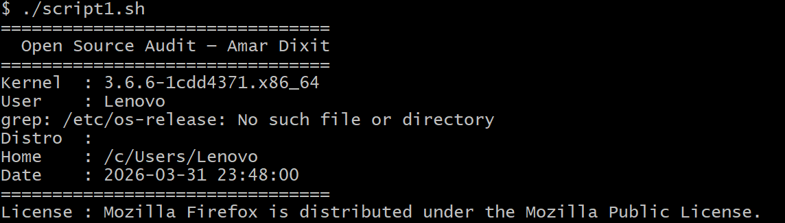

Script 2 — FOSS Package Inspector (Unit 2)
#!/bin/bash
# Script 2: FOSS Package Inspector
# Set your chosen software here
PACKAGE="firefox" # e.g. httpd, mysql, vlc, firefox
# Check if package is installed
if rpm -q $PACKAGE &>/dev/null; then
echo "$PACKAGE is installed."
rpm -qi $PACKAGE | grep -E 'Version|License|Summary'
else
echo "$PACKAGE is NOT installed."
fi
# Case statement that prints a one-line
# philosophy note about the package based on its name
case $PACKAGE in
httpd)
echo "Apache: the web server that built the open internet"
;;
mysql)
echo "MySQL: open source at the heart of millions of apps"
;;
firefox)
echo "Firefox: protecting the internet as a global public resource"
;;
vlc)
echo "VLC: the free and open source multimedia player that plays everything"
;;
git)
echo "Git: distributed version control that revolutionized collaboration"
;;
python3)
echo "Python: empowering developers with readable and versatile code"
;;
*)
echo "$PACKAGE: an essential piece of the open-source ecosystem"
;;
esac
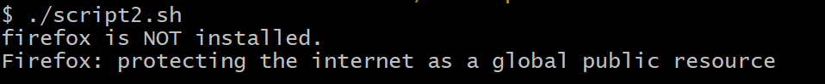

Script 3 — Disk and Permission Auditor (Unit 2)
#!/bin/bash
# Script 3: Disk and Permission Auditor
DIRS=("/etc" "/usr/bin" "/tmp")
echo "Directory Audit Report"
echo "----------------------"
for DIR in "${DIRS[@]}"; do
if [ -d "$DIR" ]; then
PERMS=$(ls -ld "$DIR" | awk '{print $1, $3, $4}')
SIZE=$(du -sh "$DIR" 2>/dev/null | cut -f1)
echo "$DIR => Permissions: $PERMS | Size: $SIZE"
else
echo "$DIR does not exist on this system"
fi
done
CONFIG_DIR="/etc/firefox"
echo ""
echo "Software Config Directory Check"
echo "-------------------------------"
if [ -d "$CONFIG_DIR" ]; then
CONFIG_PERMS=$(ls -ld "$CONFIG_DIR" | awk '{print $1, $3, $4}')
echo "$CONFIG_DIR => Permissions: $CONFIG_PERMS"
else
echo "Notice: $CONFIG_DIR does not exist on this system."
fi 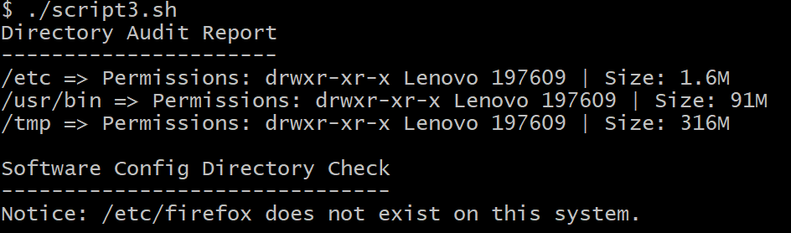

Script 4 — Log File Analyzer (Units 2 & 5)
#!/bin/bash
# Script 4: Log File Analyzer
# Usage: ./log_analyzer.sh /var/log/messages
LOGFILE=$1
KEYWORD=${2:-"error"} # Default keyword is 'error'
COUNT=0

if [ ! -f "$LOGFILE" ]; then
echo "Error: File $LOGFILE not found."
exit 1
fi
while true; do
# The -s flag checks if the file exists AND is greater than 0 bytes
if [ -s "$LOGFILE" ]; then
break # File is not empty, break out of the loop and continue
else
echo "Warning: The file '$LOGFILE' is empty."
read -p "Please enter a new log file path: " LOGFILE
# We need to re-verify the new input actually exists
if [ ! -f "$LOGFILE" ]; then
echo "Error: File $LOGFILE not found."
exit 1
fi
fi
done
# Original looping logic to count keywords
while IFS= read -r LINE; do
if echo "$LINE" | grep -iq "$KEYWORD"; then
COUNT=$((COUNT + 1))
fi
done < "$LOGFILE"
echo "Keyword '$KEYWORD' found $COUNT times in $LOGFILE"
echo "--------------------------------"
echo "Last 5 matching lines:"
echo "--------------------------------"
grep -i "$KEYWORD" "$LOGFILE" | tail -n 5 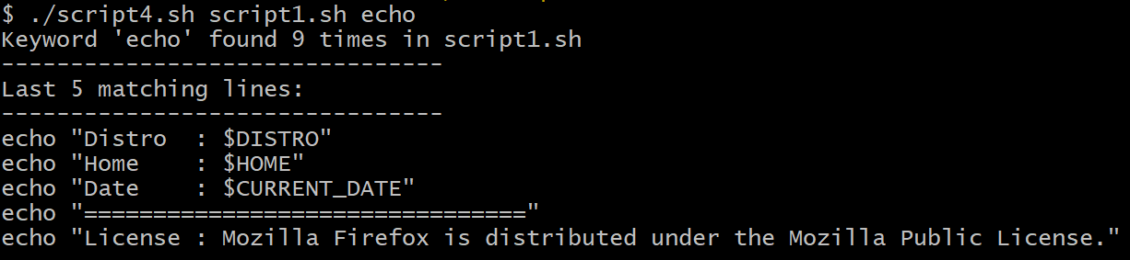

Script 5 — The Open Source Manifesto Generator (Unit 5)
#!/bin/bash
# Script 5: Open Source Manifesto Generator
echo "Answer three questions to generate your manifesto."
echo ""
read -p "1. Name one open-source tool you use every day: " TOOL
read -p "2. In one word, what does 'freedom' mean to you? " FREEDOM
read -p "3. Name one thing you would build and share freely: " BUILD
DATE=$(date '+%d %B %Y')
OUTPUT="manifesto_$(whoami).txt"
echo "--- The Open Source Manifesto ---" > "$OUTPUT"
# Append the rest of the paragraph to the file using >>
echo "Date: $DATE" >> "$OUTPUT"
echo "" >> "$OUTPUT"
echo "I believe in a digital world built on collaboration and transparency." >> "$OUTPUT"
echo "Every single day, tools like $TOOL empower me to create, learn, and grow." >> "$OUTPUT"
echo "In the realm of software and beyond, true freedom means $FREEDOM." >> "$OUTPUT"
echo "Because of the open-source community's immense generosity, I commit to paying it forward." >> "$OUTPUT"
echo "Driven by this philosophy, I pledge to one day build $BUILD and share it freely with the world." >> "$OUTPUT"
echo "Manifesto saved to $OUTPUT"
cat "$OUTPUT"